**CSCI 5531.01 Advanced Operating Systems**

**Project Documentation**

**Programmer:** Sumanjali Tirunagaru

**Course:** CSCI 5531.01

**Date:** March 26, 2018

**Project:** Distributed Cryptocurrency Trading System

**Environment:** Java

**Files Included:** TirunagaruP1Client.java, TirunagaruP1ClientStatus.java, userlist.txt, TirunagaruP1CoinsInterface.java, TirunagaruP1CryptoCoin.java, Cryptocoin.java, TirunagaruP1ServerDriver.java

**Purpose:** To implement client-server interaction using Remote Objects and Remote Interfaces with Java RMI API.

**Input:** IP and Port Address of system executing RMI Registry and Crypto currency details.

**Preconditions:** we need a list of user’s authentication details at server side.

**Output:** Successful RMI connection establishment between Server, Client and RMI Registry and maintain client state and details of the purchased coins.

**Algorithm:**

***TirunagaruP2Client:***

* IP address and port number through command line arguments is required.
* Connect to the RMI Registry to look for the Remote Objects using name of the reference.
* Before accessing the Coins from the RMI registry, authentication is required and using reference object, call *“****authenticate ()****”* method and give user name and password
* After successful execution and return value as “true” it is success.
* Else Send the username and passwords again.
* After Successful authentication, list the references from the RMI Registry using ***“registoryConn.list ()”*** which contains the coin references from the server.
* Select a coin to BUY or SELL
* Give the Required quantity to BUY or SELL
* To BUY or SELL, send the username, coin name, quantity and price.
* By selecting the required coins reference, call BUY or SELL function, appropriately, which returns a success or unsuccessful message.
* To know the user details, user can select the option, which eventually calls “***UserDetails (username)***” which returns all the details of the client and client’s coins.
* Methods are implemented on Server Side.
* To exit, User can select the option to logout.

***TirunagaruP2CryptoCoinInterface:***

* Authentication (), BUY (), SELL(), userdetails () Methods are declare on Server Side and implemented by the implementing class.

***TirunagaruP2CryptoCoin:***

* Holds the details of the coins in the Trading System.
* Name, abbreviated name, description, Market Cap, Volume, Price and data are declared.
* Authentication (), BUY(), SELL(), serialize(), deserialize(), userdetails() methods are to be implemented to do authentication, buy and sell operations, and serializing and deserializing the client objects.

***TirunagaruP2ServerDriver:***

* An input port number is required through command line argument and connect to the RMI Registry.
* Bind the references to the RMI Registry by the unique for each operation like: authentication, userDetails.
* Adding coins to the system using “***TirunagaruP2CryptoCoin***” class and bind to the RMI Registry using *registry.rebind()* .
* Similarly, edit the coins if required, and rebind the objects using *registry.rebind()* and remove the coin using *registry.unbind()*
* And the Server is ready after binding the required coins into the Trading system.

***TirunagaruP2ClientStatus and Cryptocoin:***

* This classes are required to hold the details of the client with username, id, purchasing power, list of < ***Cryptocoin*** > coins with attributes (coin name, price, quantity, Date)
* The objects of these classes are serializable.

***Summary:***

In this project Java RMI API is implemented in which there is a server and many clients. In this we have used Java RMI registry and client-server interaction with the help of Remote Objects and Remote Interfaces.

The ***Server*** process creates the objects (coins, Authentication, userDetails) of class “***TirunagaruP2CryptoCoin”*** and bind them in the RMI Registry.

We have used Interfaces for Server and Client, where the methods are implemented on Server and are used by client by calling them using Reference Object.

Interface named TirunagaruP2CoinsInterface has all the services information like authenticate, Buy, Sell, user details.

The Buy () method is called by the client using Remote Reference, this method updates the purchased buy information about coins and serializes the client details.

The Sell () method is called by the client using Remote Reference, this method deserialize the client details, updates the selling information of the coins and again serializes the details for the next login.

***Steps to run the program:***

***Server Side:***

* open the command prompt, compile
* *Cryptocoin.java*
* *TirunagaruP2CryptoCoinInterface.java*
* *TirunagaruP2CryptoCoin.java*
* *TirunagaruP2ClientStatus.java*
* *TirunagaruP2ServerDriver.java*
* Using rmic complier, compile *TirunagaruP2CryptoCoin* class file
  + rmic *TirunagaruP2CryptoCoin*
* Start the RMI Registry
  + rmiregistry <port number>
* Run *TirunagaruP2ServerDriver class file.*
* *java TirunagaruP1ServerDriver portnumber*

***Client******Side****:*

* copy the TirunagaruP2CryptoCoin_Stub.class to the client side, c
* Compile *TirunagaruP2Client.java and TirunagaruP2CryptoCoin*.java
  + - * + *java TirunagaruP1Client IPaddress portnumber*

***Classes Included in the project:***

* *TirunagaruP1CryptoCoin.java*
* *TirunagaruP1CoinInterface.java*
* *TirunagaruP2ClientStatus.java*
* *TirunagaruP2ServerDriver*
* *Cryptocoin.java*
* *TirunagaruP2Client.java*

***Output Screenshots:***

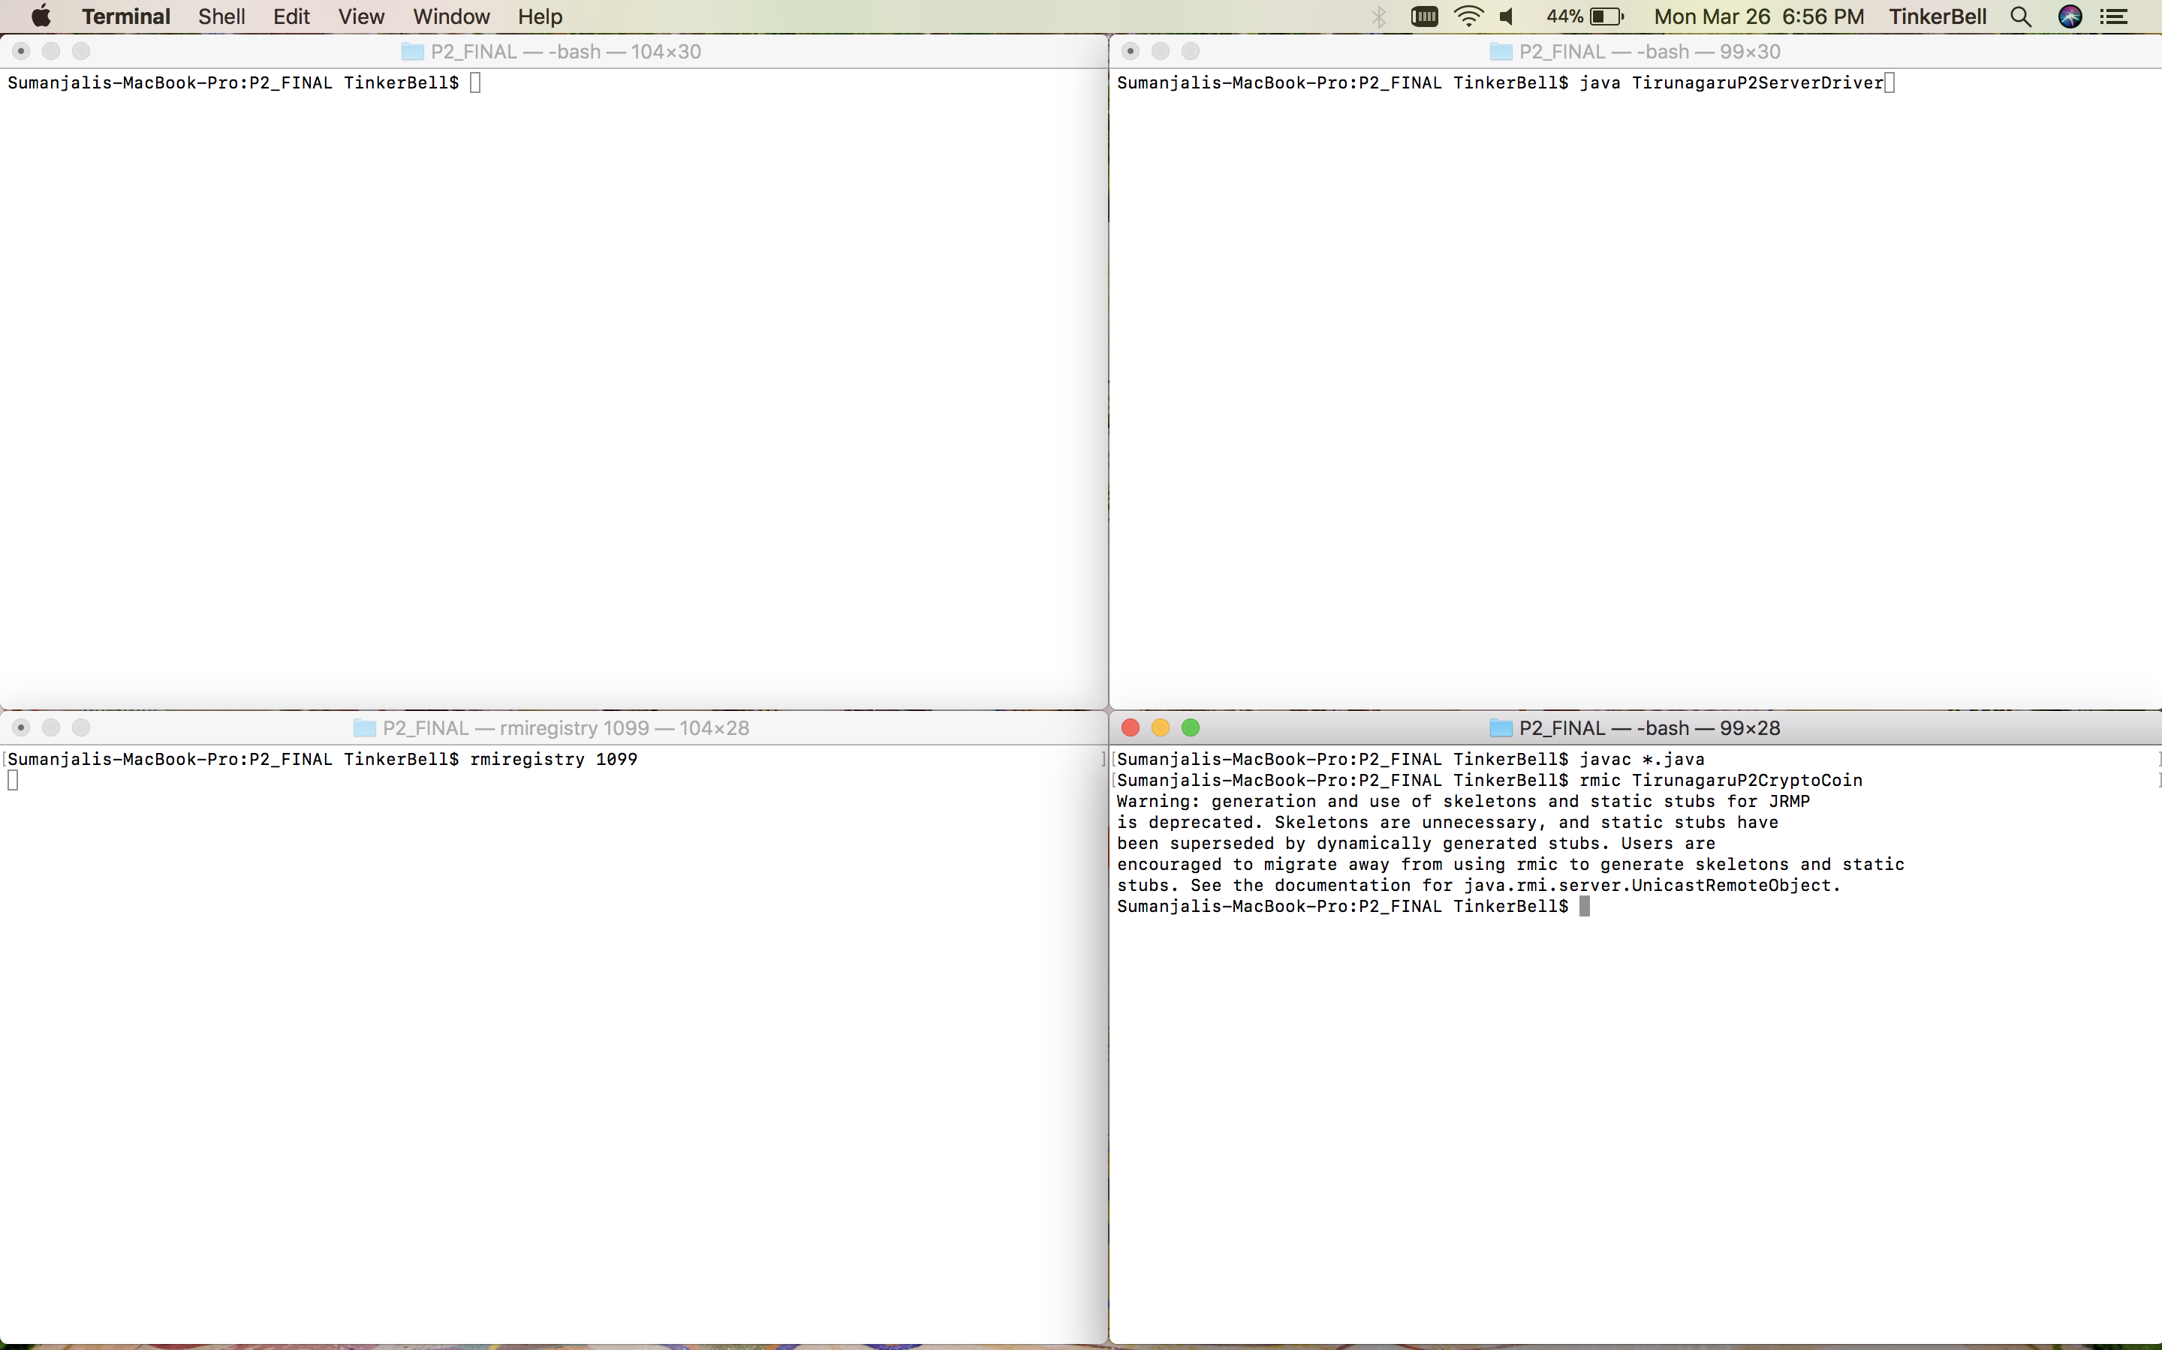

***fig1. Compiling all files and compling using rmic***

***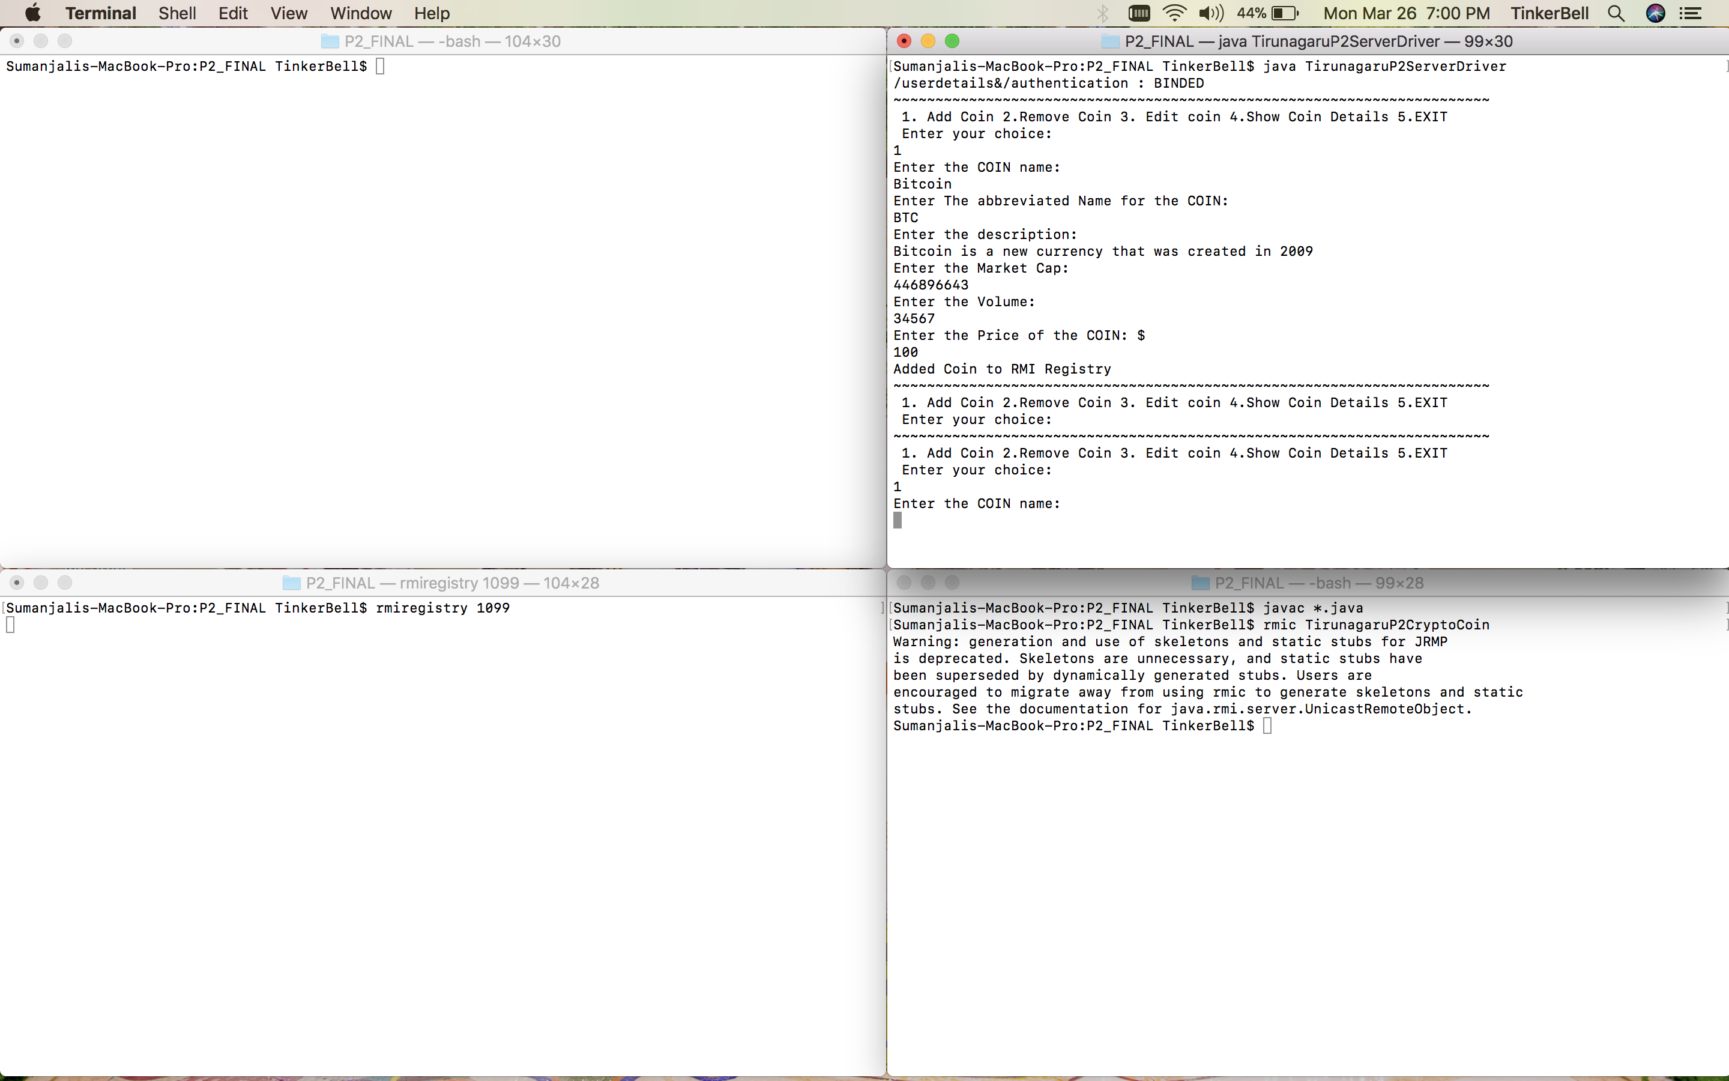  
fig2. starting rmi registry, running Server and binding the coin details***

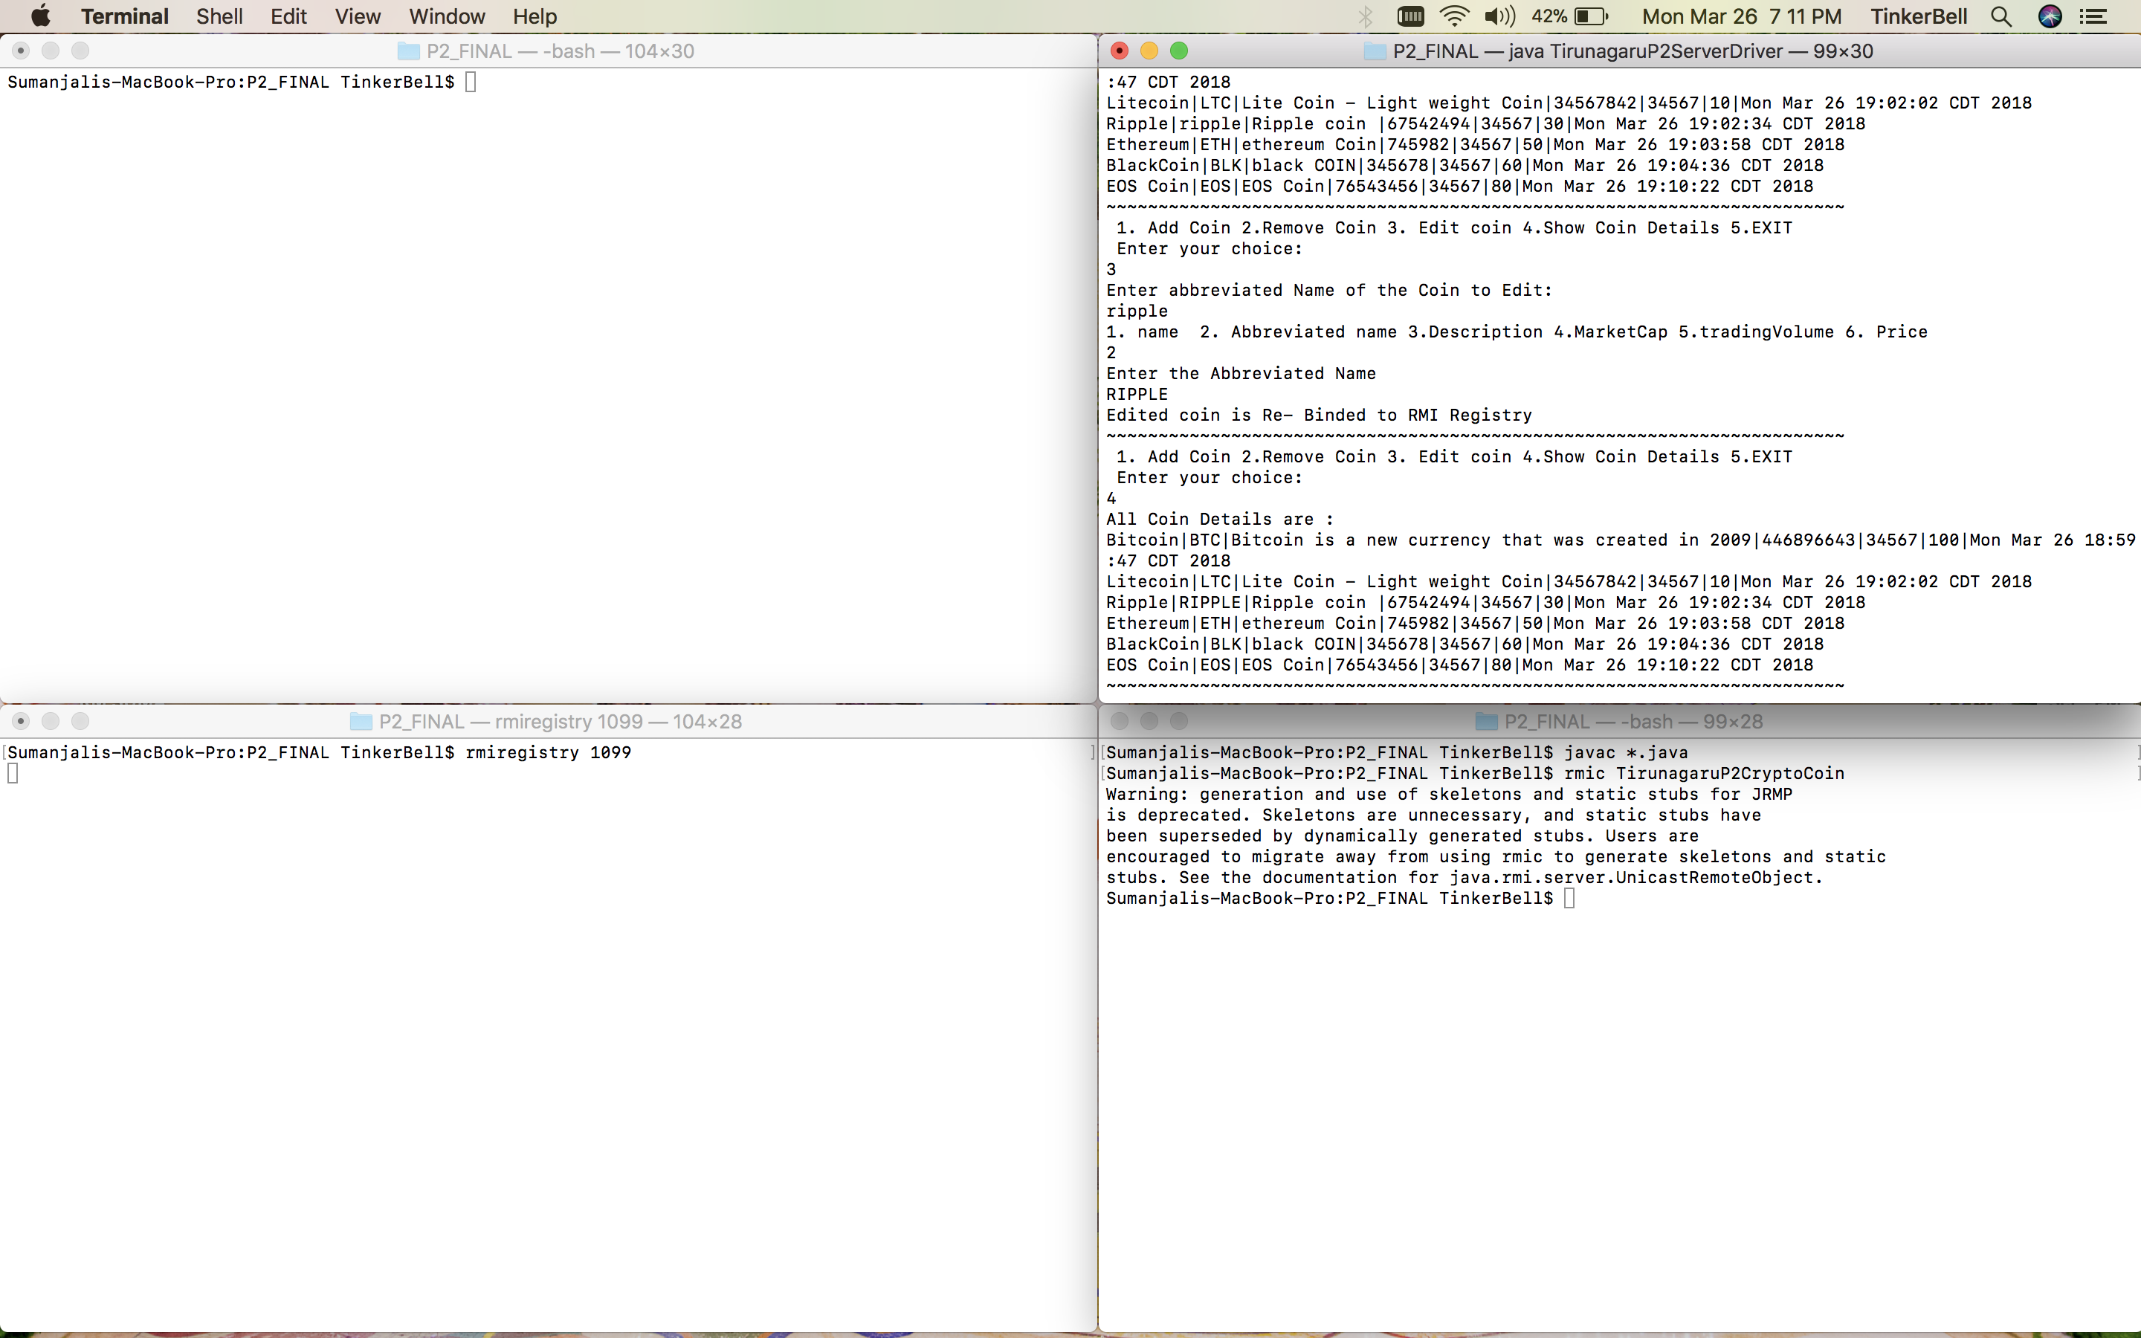

***fig3. Showing coin details***

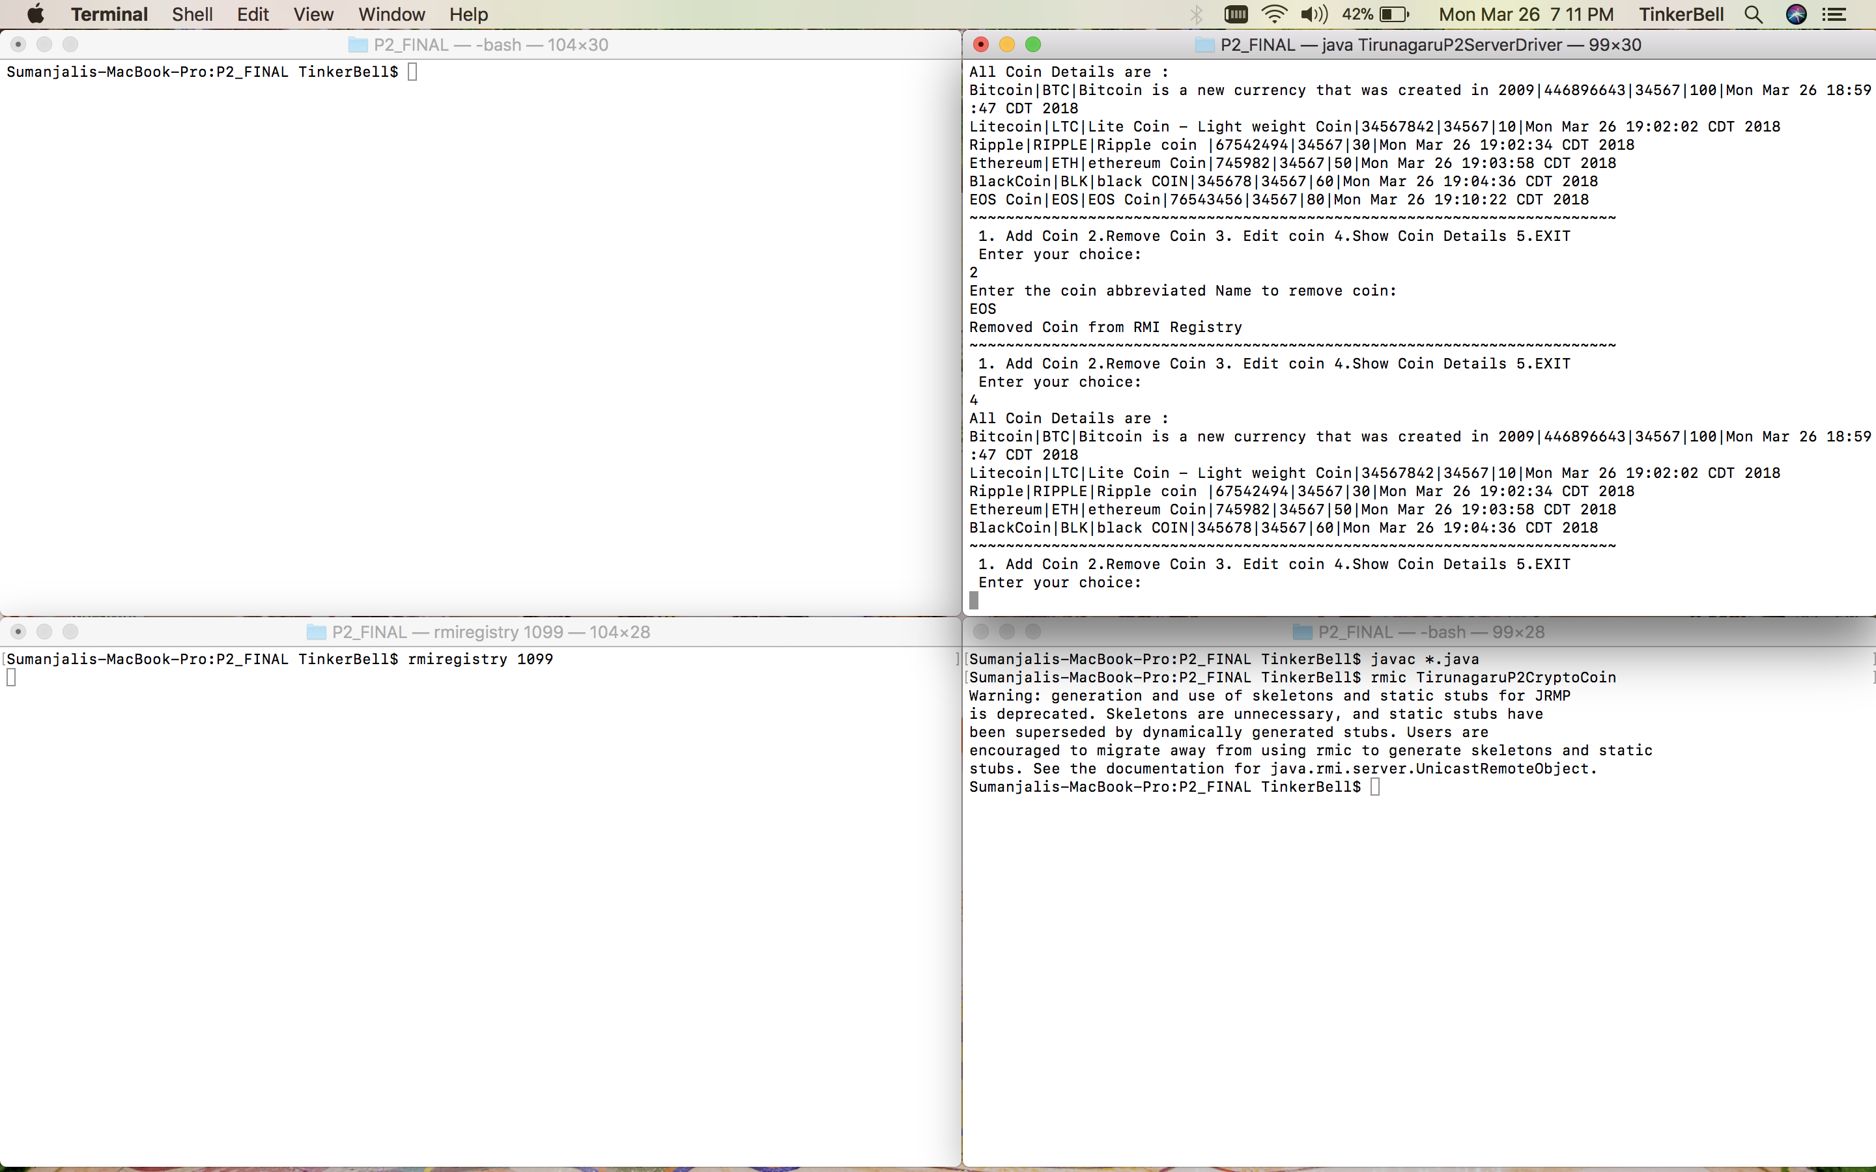

***fig4.Removing the coin from Rmi registry.***

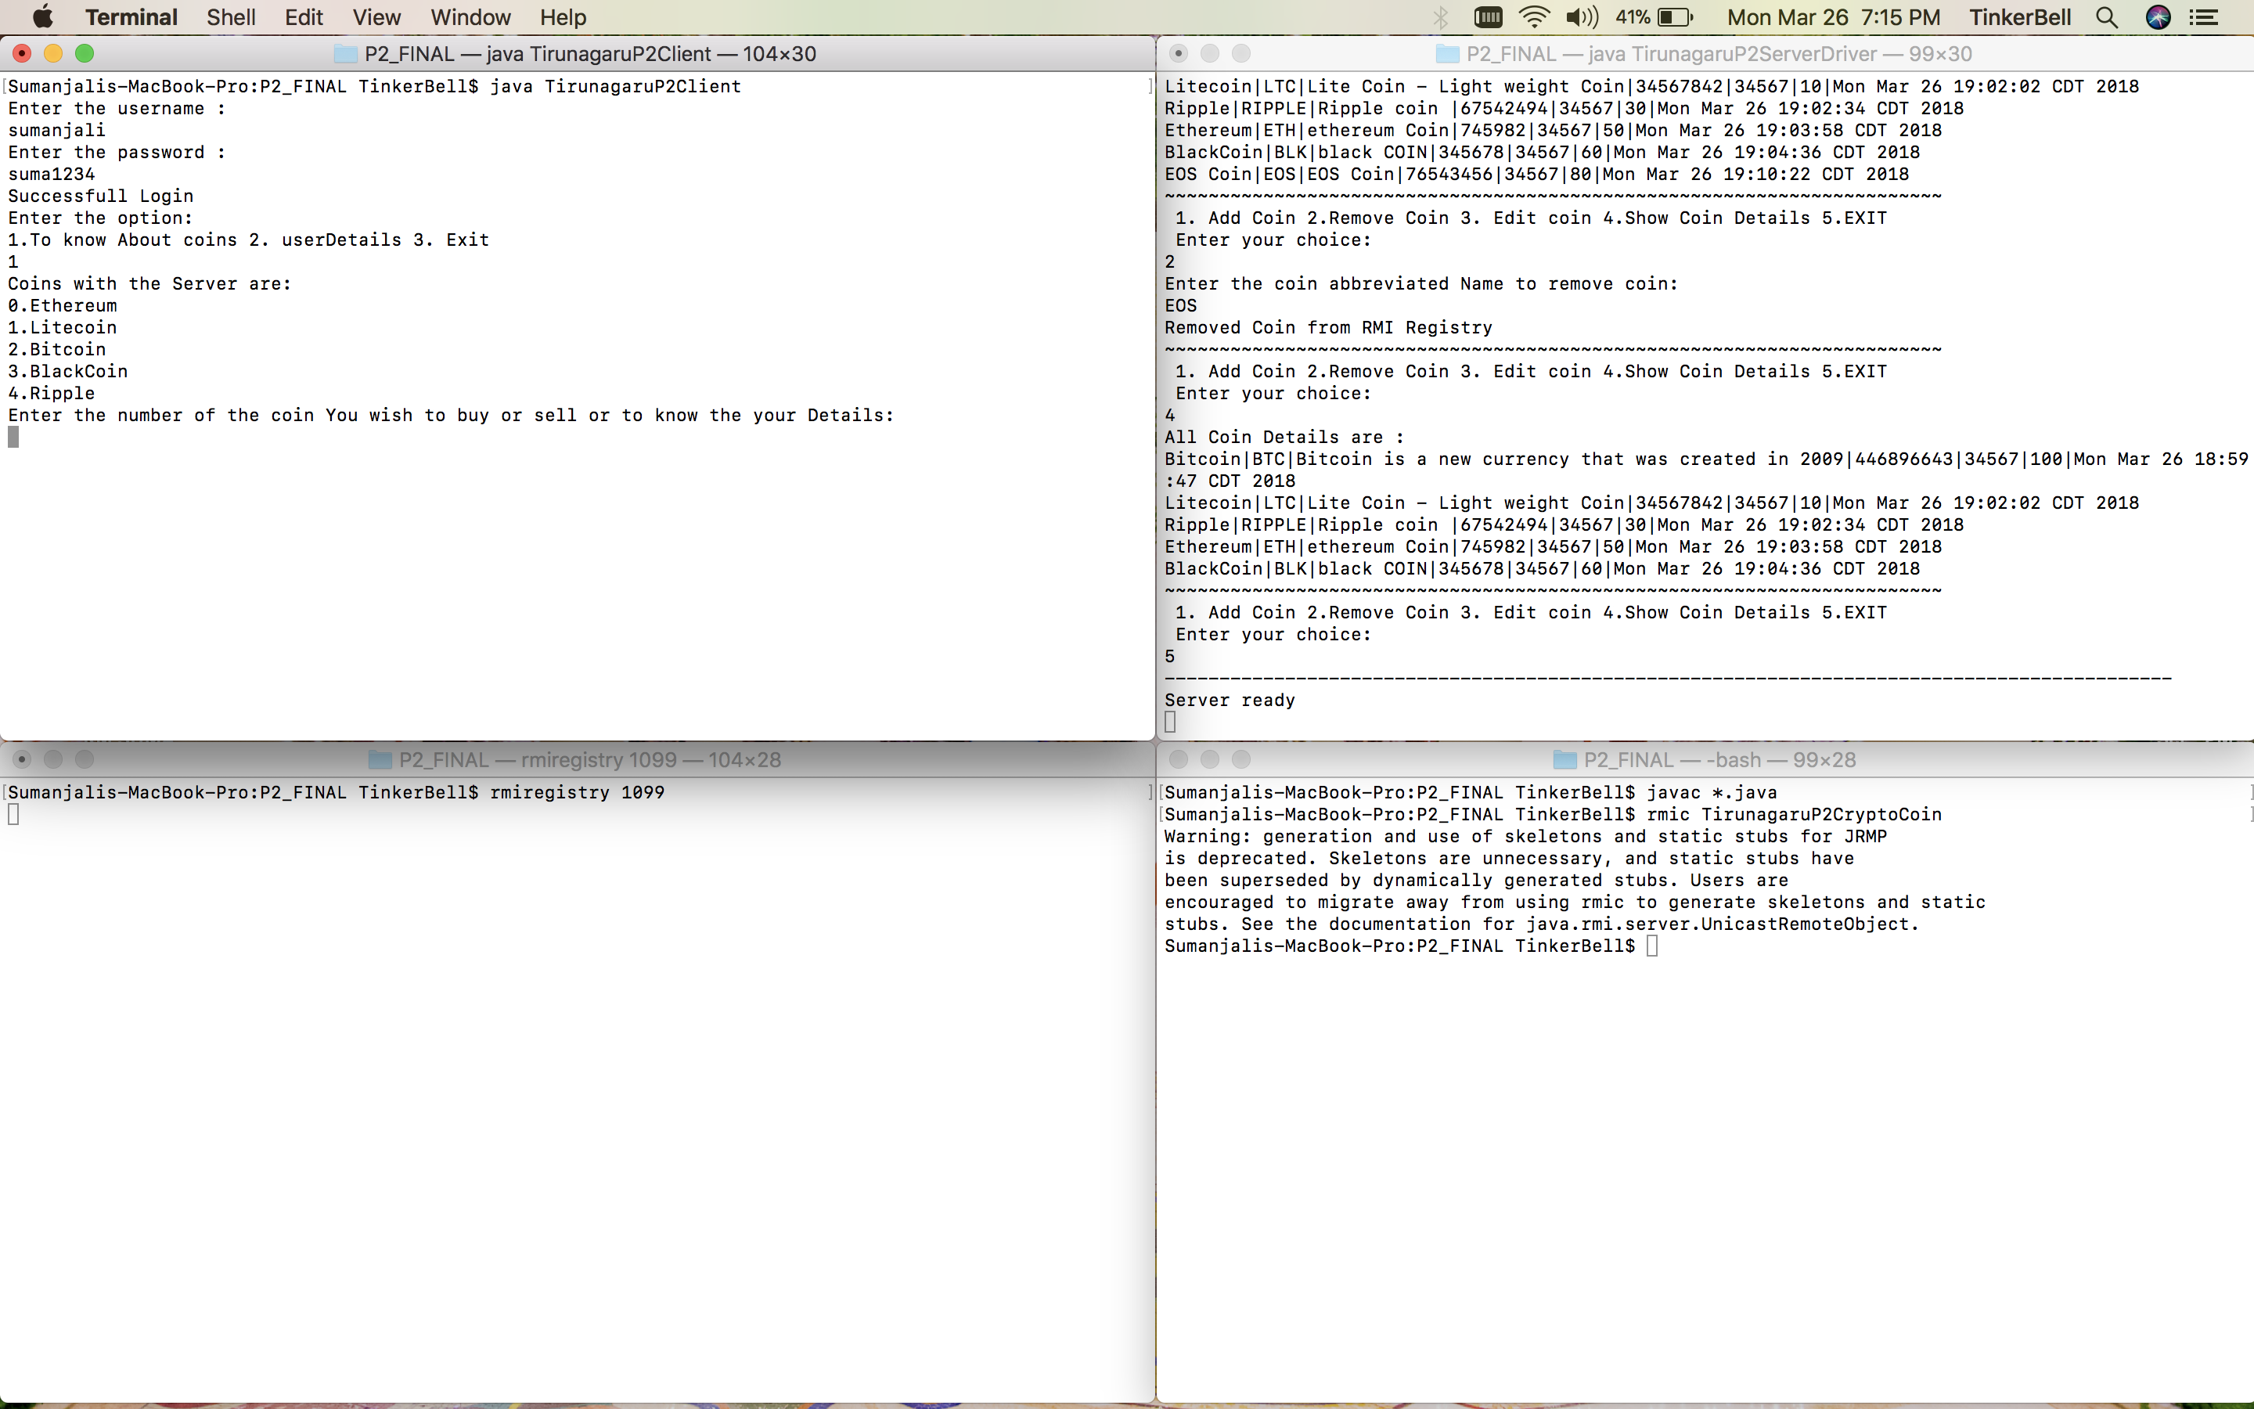

***fig5. run the client and authentication of client and looking for coins***

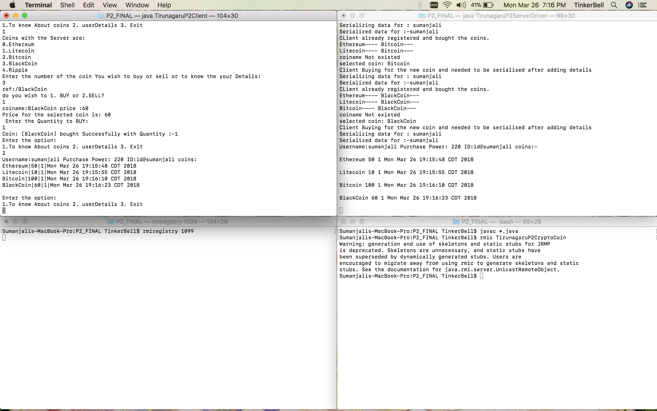

***fig6. Coins bought and showing the coins details.***

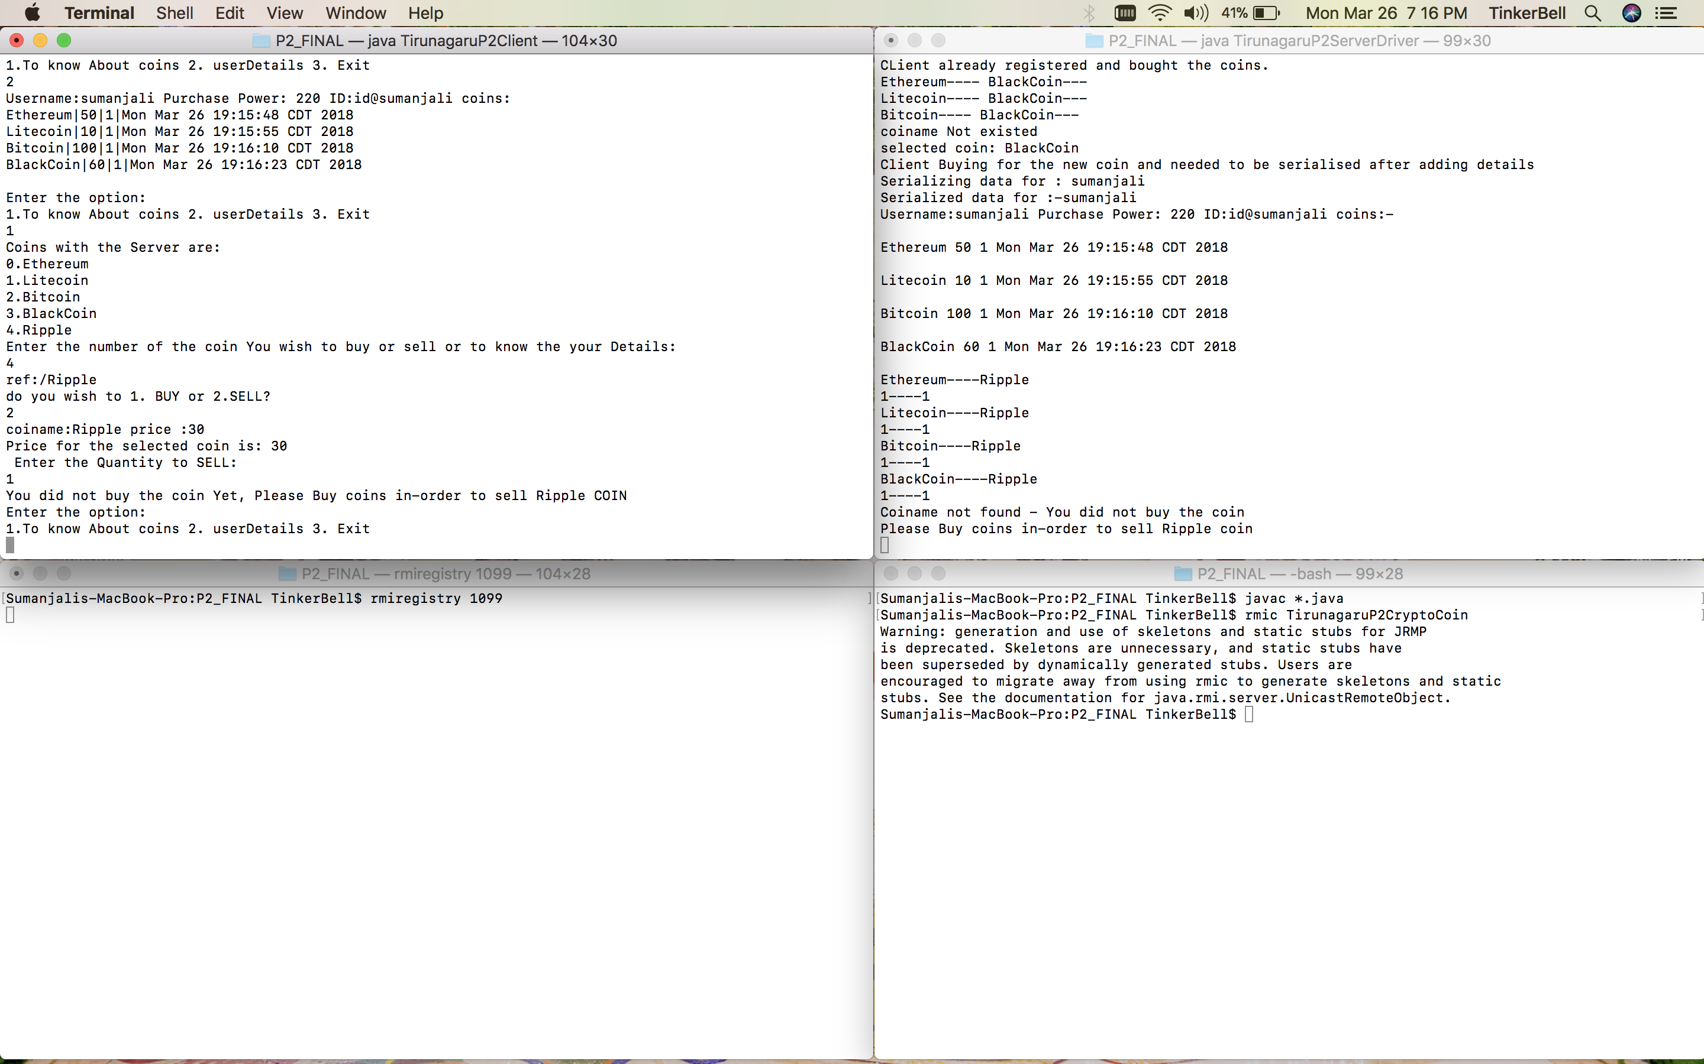

***Fig7. selling the coins, but no coins to sell the required coin.***

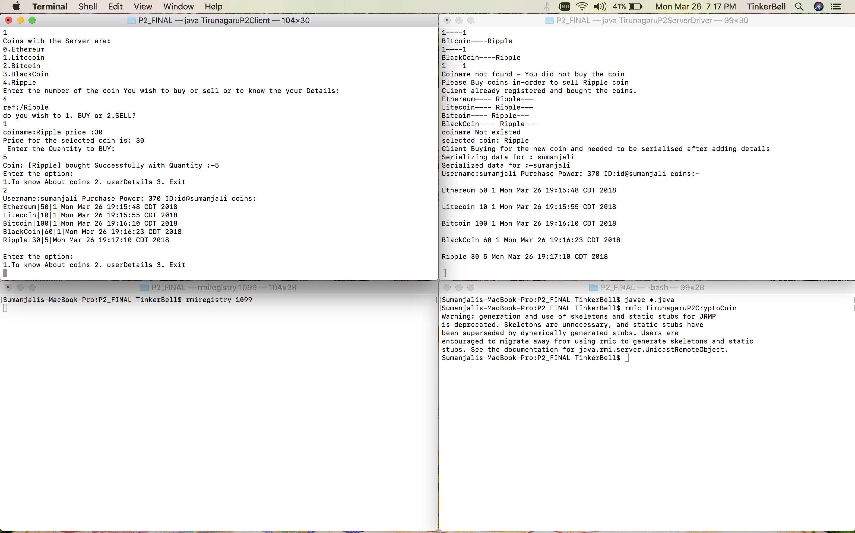

***fig8. Showing user details on Client side.***

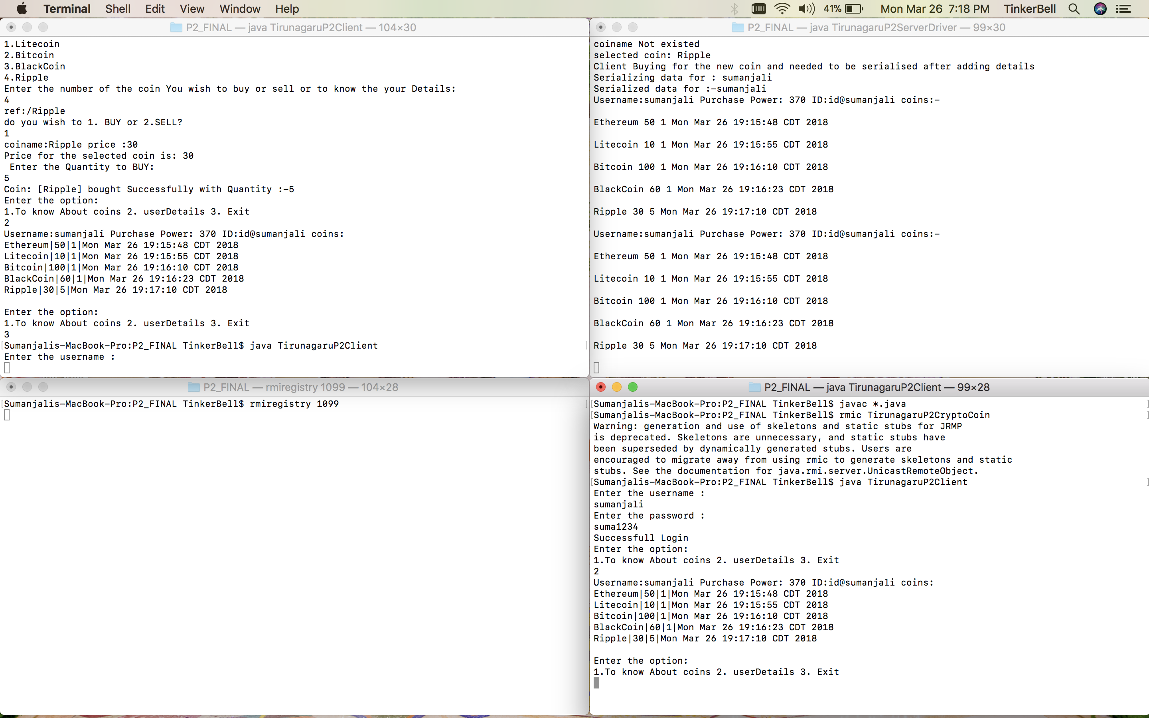

***fig9. user logged out and user logged in 4th screen using same user name but details are restored.***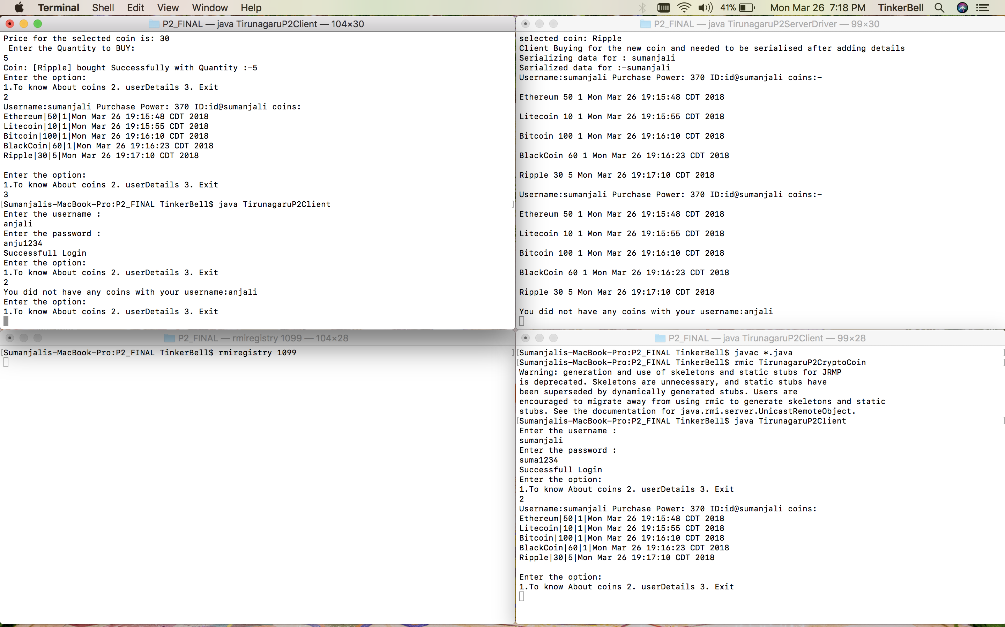

***fig10. New user logged in the 1st screen with other details.***

***Class Diagram***

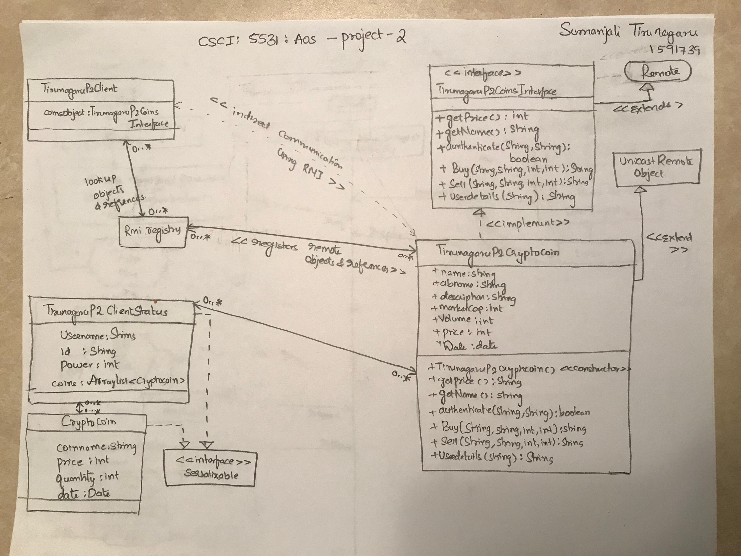

***Flow Chart Diagram***

